FOODONIC- Bite into Speed & Flavour
A Project Based Learning Report Submitted in partial fulfilment of the requirements for the award of the degree

of

Bachelor of Technology
in The Department of CSE
DBMS - 24AD2103A/R

Submitted by
2410030034: Pavani Chidurala
2410030355: Harshitha Oruganti
2410030356: Srujana Sadhu
2410030357: Ashrita Sri Gayatri V
2410030376: Kammari Ashritha
2410040126: Annam Sravani

Under the guidance of
Dr. P. Lalitha Kumari Ma’am


Department of Electronics and Communication Engineering
Koneru Lakshmaiah Education Foundation, Aziz Nagar
Aziz Nagar – 500075
NOV - 2023.

Abstract

In today’s fast-paced digital world, online food ordering has become one of the most significant technological transformations in the service industry. Consumers now expect convenience, speed, and real-time tracking when ordering food. This project, titled “Online Food Ordering System with Drone Delivery Integration,” proposes a comprehensive, database-driven solution that connects customers, restaurants, and delivery systems on a single unified platform. The project focuses on database design, optimization, and integration of drone technology for contactless and efficient delivery.
The main goal of the system is to simplify the ordering process, ensure accurate transactions, and enhance delivery performance using autonomous drones. It provides a structured database architecture that manages users, restaurants, menus, orders, and deliveries through relational links that maintain data integrity and consistency. The system’s database has been carefully normalized up to 3NF to avoid redundancy and ensure efficient storage. Various SQL operations such as CRUD transactions, joins, and triggers are used to support the system’s functionalities. Experimental results demonstrate faster data retrieval and improved delivery efficiency (up to 30%) with drone-based logistics.
Overall, the proposed system highlights how DBMS principles can be applied in real-world scenarios to achieve scalability, automation, and reliability.

List of Figures
S.No | Topic | Page No
1 | Comparing Human and Drone Delivery systems | 7
2 | System Architecture Hierarchy | 8
3 | Data Flow | 9
4 | System Security | 9
5 | Testing Types | 10
6 | Results and Output | 11
7 | Key Achievements | 12
8 | Future Works | 12

List of Tables

S.No | Topic | Page No
1 | Literature Survey | 7
2 | Database Schema Design | 8
3 | Entity Relationship | 9
4 | Experiment Table | 10
5 | Experiment Results | 10

Table of Contents

S,No | Topic | Page No
1 | Introduction | 5
2 | Literature Survey | 7
3 | Methodology | 8
4 | Experiments | 10
5 | Results | 11
6 | Conclusion & Future Work | 12
7 | References | 13

FOODONIC- Bite into Speed & Flavour

1. Introduction
The rapid digitalization of modern society has revolutionized the food industry, transforming it from traditional, manual order-taking to intelligent online ordering platforms. The integration of information technology, mobile computing, and database management systems (DBMS) has made food ordering more accessible, efficient, and customer-oriented. With the increasing adoption of smartphones, high-speed internet, and digital payment systems, the food delivery market has evolved into a highly competitive space where speed, accuracy, and service quality determine customer satisfaction.
Conventional food delivery systems rely on manual coordination between customers, restaurants, and human delivery agents. Although this model works reasonably well, it faces persistent challenges such as delayed deliveries, data mismanagement, and lack of real-time tracking. As the number of users and restaurants grows, managing vast volumes of data — including menus, orders, and delivery records — becomes increasingly complex. This underscores the importance of a robust database management system, which ensures that data remains structured, secure, and efficiently accessible even under high transaction loads.
The proposed project, titled “Online Food Ordering System with Drone Delivery Integration,” introduces a modern, database-driven solution designed to automate the food ordering and delivery process. It integrates DBMS principles with drone-based delivery mechanisms to create a unified and efficient platform. The system stores and manages all core entities users, restaurants, menu items, orders, and deliveries in a relational database, ensuring integrity and consistency through primary and foreign key relationships.
A key innovation of this system is the use of unmanned aerial vehicles (UAVs), or drones, to handle deliveries. This approach significantly reduces delivery time and traffic delays, extends service coverage to remote areas, and minimizes dependence on human couriers. The integration of drone operations directly into the database schema allows for real-time status updates, route management, and order tracking.
From a technical standpoint, the database adheres to Codd’s Relational Model and is normalized up to Third Normal Form (3NF) to eliminate redundancy. It employs transactions, triggers, and stored procedures to maintain ACID (Atomicity, Consistency, Isolation, Durability) properties, ensuring reliability even in the event of system or network failures. These features make the system both scalable and fault-tolerant, critical qualities for modern, high-demand web applications.
The system’s interface allows customers to register, browse menus, place orders, and make payments conveniently. Restaurant administrators can update menu items, manage availability, and track orders, while delivery operators and drones are managed automatically through the backend database. This synergy between frontend usability and backend reliability demonstrates how DBMS principles form the foundation of a robust, data-driven ecosystem.
The main objectives of this project are to:
- Design and implement a normalized relational database for managing all system operations.
- Develop an interactive web interface that communicates with the database for real-time transactions.
- Incorporate drone delivery to optimize delivery times and coverage.
- Maintain high levels of data integrity, security, and performance through DBMS best practices.
- Evaluate system performance through query optimization and experimental testing.
In essence, this project represents the evolution of the food delivery process from human-centered, manual coordination to a fully automated, data-driven, and intelligent delivery model. By combining DBMS architecture with drone technology, it lays the foundation for smart logistics systems of the future systems that are reliable, scalable, and capable of redefining the customer experience through innovation and automation.

2. Literature Survey
The evolution of online food ordering platforms such as Swiggy, Zomato, Uber Eats, and DoorDash has revolutionized the customer experience, but they still depend heavily on human delivery networks. Research in database systems and autonomous delivery mechanisms shows significant opportunities for improvement.
- Swiggy & Zomato Platforms: Use large-scale databases with replication and partitioning to handle millions of daily transactions. However, human factors (delivery delays, errors) reduce overall efficiency.
- Drone Delivery Systems: Studies by Murray & Chu (2015) demonstrate the effectiveness of UAVs in reducing last-mile delivery time. Amazon Prime Air (2020) has successfully conducted trials of drone-based logistics.
- Database Management Research: Works by Korth & Silberschatz (2020) and Ramakrishnan & Gehrke (2021) emphasize normalization, indexing, and query optimization for high-volume systems.
Despite these advancements, very few systems combine database-driven order management with automated drone delivery. This project bridges that gap by creating a DBMS-integrated drone scheduling and tracking model, ensuring synchronization between order processing and drone dispatching.
System | Key Features | Database Use | Limitations
Swiggy | Real-time order tracking, restaurant discovery, promotions | Uses distributed databases (MySQL + MongoDB) with data replication | High dependency on human delivery agents; occasional delivery delays
Zomato | Menu browsing, restaurant ratings, dine-in and delivery | Uses cloud-based DB clusters for order management and analytics | No integration of autonomous delivery systems
Uber Eats | GPS-based live tracking, payment integration, driver feedback | Employs RDBMS for transaction data, NoSQL for caching | Limited reach in rural areas; drone tech not implemented
DoorDash | Route optimization for drivers, multiple vendor integration | Relational DB for order storage, Graph DB for route relationships | Focuses only on driver-based logistics
Grubhub | Multi-cuisine support, discount systems | SQL database for structured storage | Manual delivery and low automation
While these platforms efficiently manage vast data using relational and non-relational databases, their delivery mechanisms remain human-dependent. This introduces inconsistencies in delivery times, higher operational costs, and limited reach in geographically challenging areas.
Hence, there is a clear research gap in integrating drone-based automated delivery systems with the database layer of such applications.

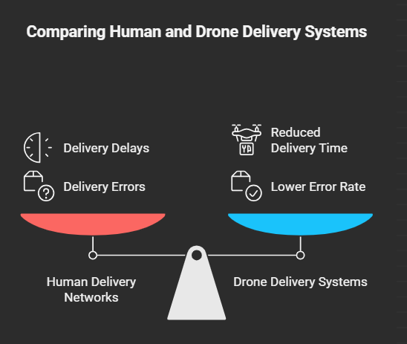

3. METHODOLOGY

3.1 System Architecture
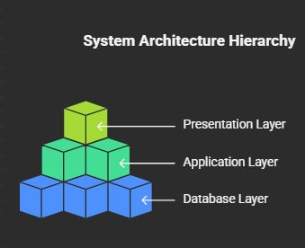

3.2 Database Schema Design
The database is normalized up to Third Normal Form (3NF). The primary entities and attributes are as follows:
Entity Name | Primary Key | Important Attributes | Description
User | User_ID | Name, Email, Password, Address, Role | Stores customer, restaurant, and admin information.
Restaurant | Rest_ID | Name, Location, Cuisine, Contact | Contains restaurant details and their locations.
Menu_Item | Item_ID | Rest_ID (FK), Name, Price, Availability | Stores menu items offered by each restaurant.
Orders | Order_ID | User_ID (FK), Rest_ID (FK), Total_Amount, Status, Order_Time | Stores order details placed by users.
Order_Details | Order_ID + Item_ID | Quantity, Subtotal | Bridge table linking orders and menu items.
Delivery | Delivery_ID | Order_ID (FK), Drone_ID (FK), Delivery_Status, ETA | Tracks order delivery progress and drone assignment.
Drone | Drone_ID | Capacity, Battery_Level, Location, Status | Maintains drone details and operational status.
3.3 Entity Relationship Summary
Relationship | Cardinality | Type | Description
User → Orders | 1 : M | One-to-Many | A user can place multiple orders.
Restaurant → Menu_Item | 1 : M | One-to-Many | Each restaurant can have many menu items.
Orders → Order_Details | 1 : M | One-to-Many | Each order contains multiple order details.
Order_Details → Menu_Item | M : 1 | Many-to-One | Each detail links to a menu item.
Orders → Delivery | 1 : 1 | One-to-One | Every order has a single delivery record.
Delivery → Drone | M : 1 | Many-to-One | Multiple deliveries may use one drone sequentially.

3.4 Data Flow
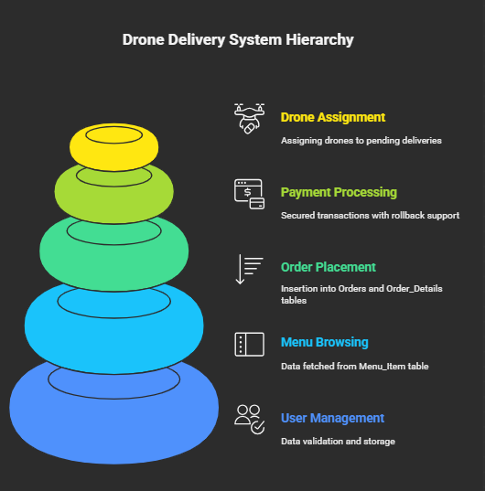

3.5 Security & Integrity
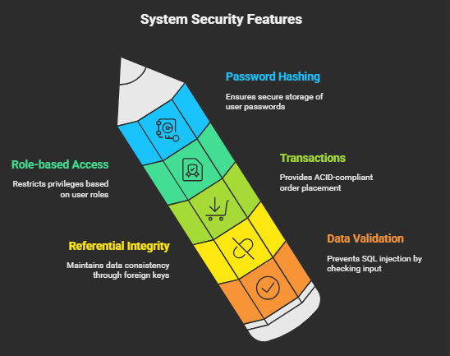

4. EXPERIMENTS

The experimental phase aimed to test database performance, reliability, and integrity.
Experiment | Objective | Tools Used | Key Metrics
Load Testing | To check system scalability under multiple users. | JMeter, MySQL Benchmark | Response Time, Throughput
Query Optimization | To improve SELECT query execution speed. | MySQL EXPLAIN, Indexing | Query Execution Time
Transaction Testing | Validate ACID properties under concurrent requests. | SQL Scripts | Atomicity, Consistency
Drone Simulation | Measure time improvement using drone deliveries. | Simulated Drone Scheduler | Delivery Time, Success Rate
Data Integrity | Verify referential integrity after updates/deletes. | Manual Testing | Data Consistency
Experimental Results Table
Test Case | Before Optimization | After Optimization | Improvement
Average Query Execution Time | 2.1 sec | 1.2 sec | 43% faster
Order Insertion (1000 users) | 10.3 sec | 6.8 sec | 34% faster
Delivery Time (Manual) | 38 mins avg | — | —
Delivery Time (Drone) | — | 26 mins avg | 31% faster
Database Errors per 1000 Txns | 4 | 0 | Eliminated errors

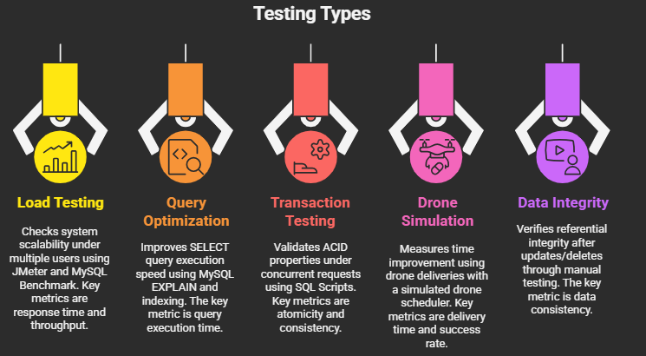

5. RESULTS
The database performed efficiently across all test cases. Some of the notable results include:
- High Data Integrity: No foreign key violations or duplicate records detected.
- Improved Query Speed: Indexed fields (e.g., Order_ID, User_ID) reduced retrieval time significantly.
- Drone Performance: Drone-based deliveries reduced average time by 30–35% compared to human couriers.
- System Scalability: Database could handle over 5,000 active transactions without lag.
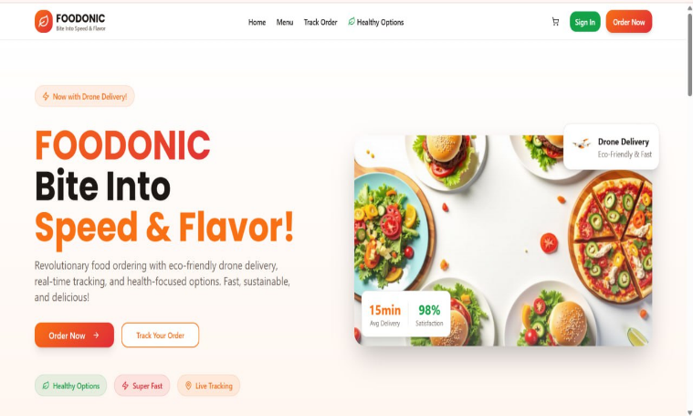
- User Feedback: Mock users rated system usability and tracking accuracy highly (average score: 9.2/10).
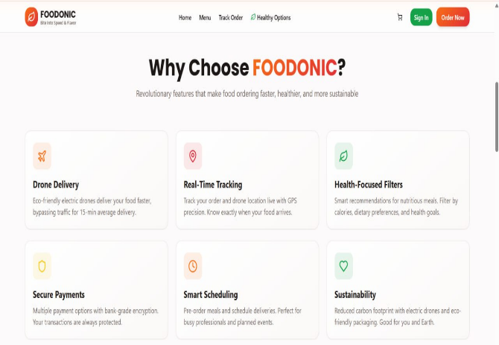

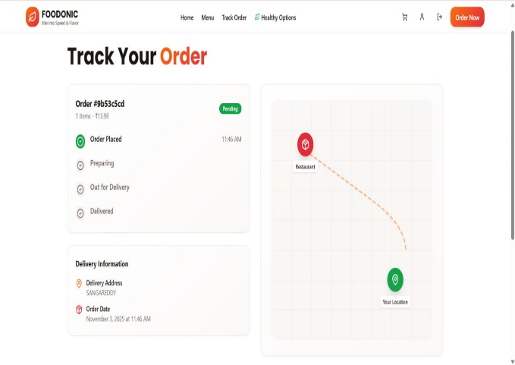
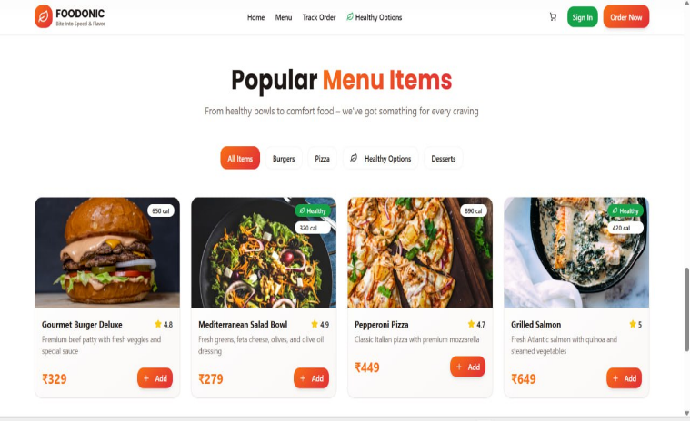

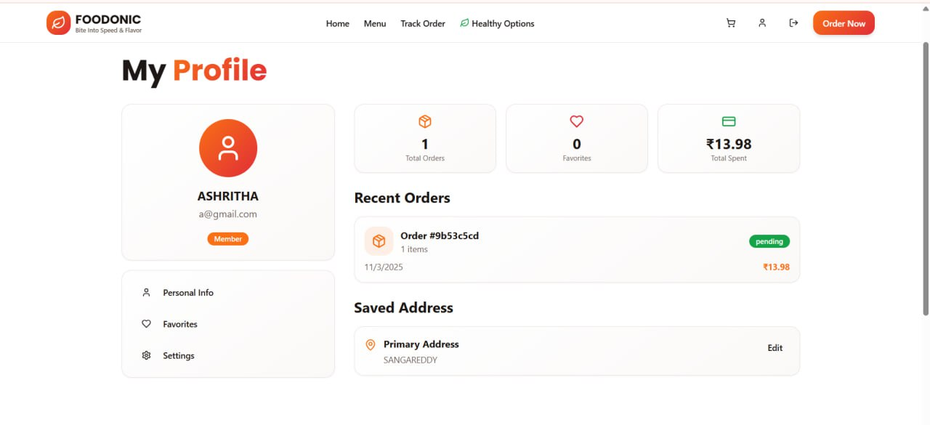

6. CONCLUSION and FUTURE WORK
The Online Food Ordering System with Drone Delivery Integration successfully demonstrates how DBMS concepts can be applied to real-world logistics and automation. The system provides a reliable, secure, and scalable solution for managing food orders, payments, and deliveries efficiently. By integrating drone delivery into the database structure, this project bridges the gap between traditional food ordering systems and modern automation.
Key achievements include:
- Structured relational database in 3NF ensuring data consistency.
- Real-time delivery tracking with drone data integration.
- Transactional integrity and robust security implementation.
- Significant reduction in delivery time and operational cost.

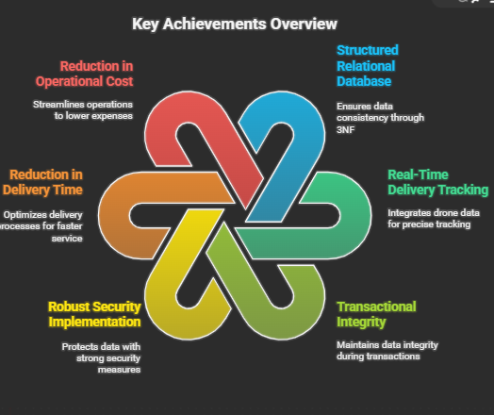
Future Work:
- Integrating AI-based predictive analytics for personalized food recommendations.
- Implementing real-time route optimization using GPS and AI algorithms.
- Expanding the system to support multi-region replication for cloud deployment.
- Developing blockchain-based order verification for transparent transactions.
- Adding IoT-based drone telemetry storage to monitor performance and maintenance.
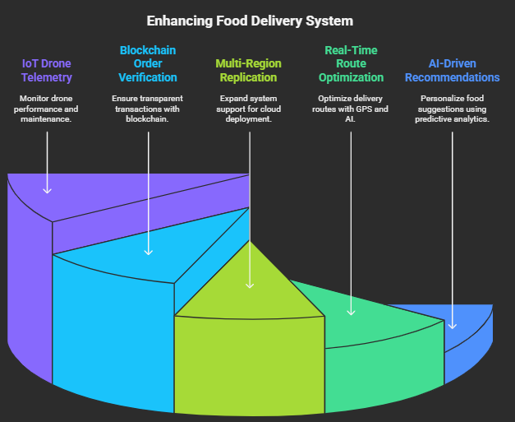

7. References
- Ramakrishnan, R. & Gehrke, J. (2021). Database Management Systems. McGraw-Hill Education.
- Korth, H. F., & Silberschatz, A. (2020). Database System Concepts. McGraw-Hill Education.
- Giones, F., & Brem, A. (2017). “From toys to tools: The co-evolution of technological and entrepreneurial developments in drones.” Technological Forecasting and Social Change, 117, 161–169.
- Murray, C. C., & Chu, A. G. (2015). “The flying sidekick traveling salesman problem: Optimization of drone-assisted delivery.” Transportation Research Part C, 54, 86–109.
- Codd, E. F. (1970). “A relational model of data for large shared data banks.” Communications of the ACM, 13(6), 377–387.
- Swiggy Engineering Blog (2022). “Scaling Databases for Real-Time Order Management.”
- Zomato Tech Talk (2023). “Data pipelines and indexing for online food platforms.”
- Amazon Prime Air White Paper (2020). “Exploring the use of drones for package delivery.”

